BANK LOAN

1. Total Loan Applications

select count(id) as total_applications from bank_loan



1. MTD loan Applications

SELECT

count(id) as Total_Applications from financial_loan where

MONTH(STR_TO_DATE(issue_date, '%Y-%m-%d')) = 12 ;



PMTD Loan Applications

SELECT

count(id) as Total_Applications from financial_loan where

MONTH(STR_TO_DATE(issue_date, '%Y-%m-%d')) = 11;



1. MTD_Total Funded Amount

SELECT SUM(loan_amount) as MTD_Total_Funded_Amount from financial_loan

WHERE month(str_to_date(issue_date, '%y-%m-%d')) = 12



1. PMTD_Total Funded Amount

SELECT SUM(loan_amount) as PMTD_Total_Funded_Amount from financial_loan

WHERE month(str_to_date(issue_date, '%y-%m-%d')) = 11;



1. Total_Amount_Received

SELECT SUM(total_payment) as Total_Amount_Received from financial_loan



1. MTD_Total_Amount_Received

SELECT SUM(total_payment) as MTD_Total_Amount_Received from financial_loan

where month(str_to_date(issue_date, '%y-%m-%d')) = 12



1. PMTD_Total_Amount_Received

SELECT SUM(total_payment) as PMTD_Total_Amount_Received from financial_loan

where month(str_to_date(issue_date, '%y-%m-%d')) = 11



1. Average Interest Rate

SELECT ROUND(AVG(int_rate) , 4) * 100 as Average_Interest_Rate from financial_loan



1. MTD_Average_Interest_Rate

SELECT ROUND(AVG(int_rate) , 4) * 100 as MTD_Average_Interest_Rate from financial_loan

where month(str_to_date(issue_date, '%y-%m-%d')) = 12



1. PMTD_Average_Interest_Rate

SELECT ROUND(AVG(int_rate) , 4) * 100 as PMTD_Average_Interest_Rate from financial_loan

where month(str_to_date(issue_date, '%y-%m-%d')) = 11



1. Average dti ratio

SELECT round(avg(dti), 4) *100 as Average_dti from financial_loan



1. MTD_Average dti

SELECT round(avg(dti), 4) *100 as MTD_Avg_dti from financial_loan

WHERE MONTH(str_to_date(issue_date, '%y-%m-%d')) =12;



1. PMTD Average dti ratio

SELECT round(avg(dti), 4) *100 as PMTD_Avg_dti from financial_loan

WHERE MONTH(str_to_date(issue_date, '%y-%m-%d')) =11;



1. Good Loan Percentage

select

(count(CASE WHEN loan_status='Fully Paid' or loan_status = 'Current' then id end)*100) /

count(id) as Good_Loan_Percentage

from financial_loan;



1. Good Loan Applications Count

select count(id) as Good_Loan_Applications from financial_loan

where loan_status ='Fully Paid' OR loan_status ='Current';



1. Good loan Funded Amount

select sum(loan_amount) as Good_Loan_Funded_Amount from financial_loan

where loan_status in ('Fully Paid','Current');



1. Good loan received amount

select sum(total_payment) as Good_Loan_Received_Amount from financial_loan

where loan_status in ('Fully Paid','Current');



1. Bad Loan Amount Percentage

select

(count(case when loan_status = 'Charged Off' then id end) * 100.0) /

count(id) as Bad_Loan_Percentage

from financial_loan;



1. Bad Loan Applications

select count(id) as Bad_Loan_Applications from financial_loan

where loan_status = 'charged off'



1. Bad loan Funded Amount

select sum(loan_amount) as Bad_loan_funded_amount from financial_loan

where loan_status = 'charged off'



1. Bad loan Amount Received

select sum(total_payment) as Bad_loan_amount_received from financial_loan

where loan_status = 'charged off'



**LOAN STATUS**

select

loan_status,

count(id) as Total_Loan_Applications,

SUM(total_payment) as Total_Amount_Received,

sum(loan_amount) as Total_Funded_Amount,

AVG(int_rate * 100) as Interest_rate,

AVG(dti * 100) as DTI

FROM financial_loan

group by loan_status;

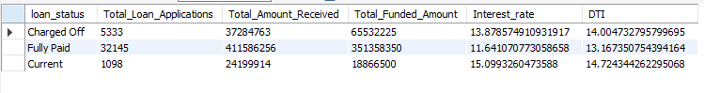

**MTD Level Loan Status :**

select

loan_status,

SUM(total_payment) as MTD_Total_Amount_Received,

sum(loan_amount) as MTD_Total_Funded_Amount

FROM financial_loan

WHERE MONTH(str_to_date(issue_date , '%y-%m-%d')) = 12

group by loan_status;

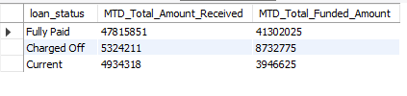

DASHBOARD -2

MONTHLY Trend:

SELECT

month(str_to_date(issue_date, '%y-%m-%d')) as Month_Number,

monthname(str_to_date(issue_date, '%y-%m-%d')) as Month_Name,

count(id) as Total_Loan_Applications,

sum(loan_amount) as Total_Funded_Amount,

sum(total_payment) as Total_Received_Amount

from financial_loan

group by month(str_to_date(issue_date, '%y-%m-%d')) , monthname(str_to_date(issue_date, '%y-%m-%d'))

order by month(str_to_date(issue_date, '%y-%m-%d')) ;

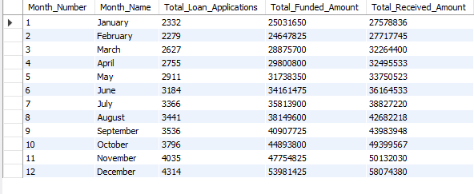

2. **Regional Level Analysis by State :**

SELECT

address_state,

count(id) as Total_Loan_Applications,

sum(loan_amount) as Total_Funded_Amount,

sum(total_payment) as Total_Received_Amount

from financial_loan

group by address_state

order by count(id) desc ;

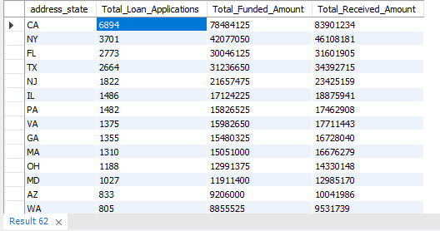

3**. Loan Term Analysis** :

SELECT

term,

count(id) as Total_Loan_Applications,

sum(loan_amount) as Total_Funded_Amount,

sum(total_payment) as Total_Received_Amount

from financial_loan

group by term

order by term ;

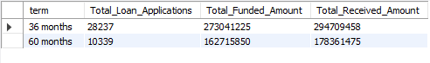

4. **Employee Length Analysis:**

SELECT

emp_length,

sum(loan_amount) as Total_Funded_Amount,

sum(total_payment) as Total_Received_Amount

from financial_loan

group by emp_length

order by count(id) desc;

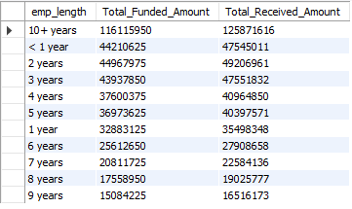

5. **Purpose wise Analysis**

SELECT

purpose,

sum(loan_amount) as Total_Funded_Amount,

sum(total_payment) as Total_Received_Amount

from financial_loan

group by purpose

order by count(id) desc;

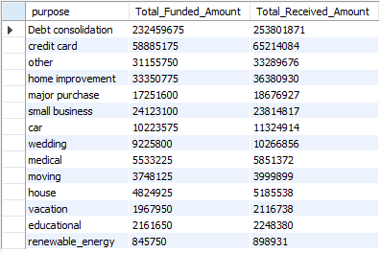

Ownership Wise :

SELECT

home_ownership,

count(id) as Total_Applications,

sum(loan_amount) as Total_Funded_Amount,

sum(total_payment) as Total_Received_Amount

from financial_loan

group by home_ownership

order by count(id) desc;

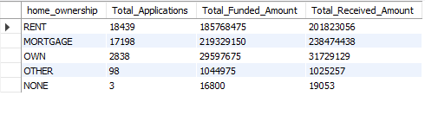

Power BI :

**DAX functions 1:**

“PMTD Loan Applications = CALCULATE([Total Loan Applications],DATESMTD(DATEADD('Date Table'[Date],-1,MONTH))”

This DAX (Data Analysis Expressions) function is used to calculate the total loan applications for the current month-to-date (MTD), compared to the previous month. Let's break down the function step by step:

1. **CALCULATE:** This function is used to apply filters to a calculation. It takes an expression and one or more filter arguments. In this case, the expression is `[Total Loan Applications]`, which likely represents a measure that calculates the total number of loan applications.

2. **DATESMTD:** This function returns a table of dates for the current month-to-date (MTD) period. It requires a date column as its argument. In this case, it's applied to the 'Date Table'[Date] column.

3. **DATEADD:** This function is used to add or subtract a specified number of units from a date. Here, it's subtracting 1 month from each date in the 'Date Table'[Date] column. This effectively gives you the previous month.

4. **MONTH:** The MONTH function extracts the month number from a date. It's used here to get the month number of the date one month ago.

5. **Total Loan Applications:** This is likely a measure defined elsewhere in the Power BI model. It calculates the total number of loan applications.

Putting it all together, the DAX expression calculates the total loan applications for the current month-to-date (MTD) period, but compares it with the total loan applications for the previous month's MTD period. It achieves this by subtracting 1 month from each date in the 'Date Table'[Date] column and then calculating the total loan applications within that time frame. This allows for month-over-month comparison of loan applications.

**DAX Function 2:**

“MTD DTI = CALCULATE(TOTALMTD([Average DTI],'Date Table'[Date]))”

1. **CALCULATE:** This function modifies the context in which the calculation is made. It takes an expression and one or more filter arguments.

2. **TOTALMTD:** This function calculates a total for a column across a specified date range, which is Month-to-Date (MTD) in this case. It requires two arguments: the expression to aggregate (in this case, `[Average DTI]`) and the date column to use for the calculation (`'Date Table'[Date]`).

3. **[Average DTI]:** This likely represents a measure that calculates the average Debt-to-Income (DTI) ratio for loan applications. It's the expression being aggregated within the MTD calculation.

4. **'Date Table'[Date]:** This is the date column used to define the date range for the MTD calculation. It's likely a column from a Date Table in your Power BI model.

Putting it all together, the DAX expression calculates the Month-to-Date (MTD) average Debt-to-Income (DTI) ratio for loan applications. It does this by aggregating the `[Average DTI]` measure across the dates in the 'Date Table'[Date] column within the current month-to-date period. This allows you to see the average DTI ratio for loan applications dynamically as the month progresses.